Appendix X
EJB Quick Reference Guide
This appendix is a quick reference for programmers to use during EJB development. In the first section of this appendix, you’ll find diagrams illustrating what’s really going on in an EJB system. These diagrams were taken directly from the EJB specification; I’ve condensed the diagrams and commented them to clarify their meaning. You’ll also find summaries and explanations of each method in the EJB architecture, as well as a transaction reference.
Session Bean Diagrams
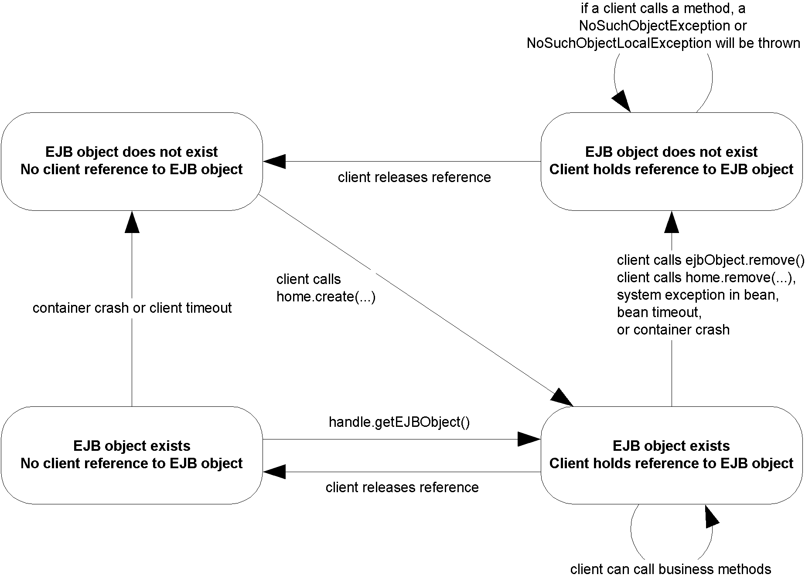
Figure X.X The client’s view of a session bean object lifecycle.
Stateless Session Bean Diagrams
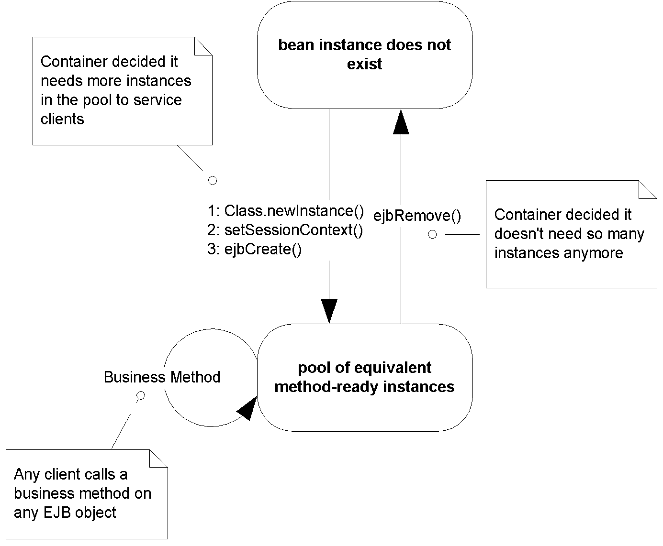
Figure X.X The lifecycle of a stateless session bean. Each method call shown is an invocation from the container to the bean instance.
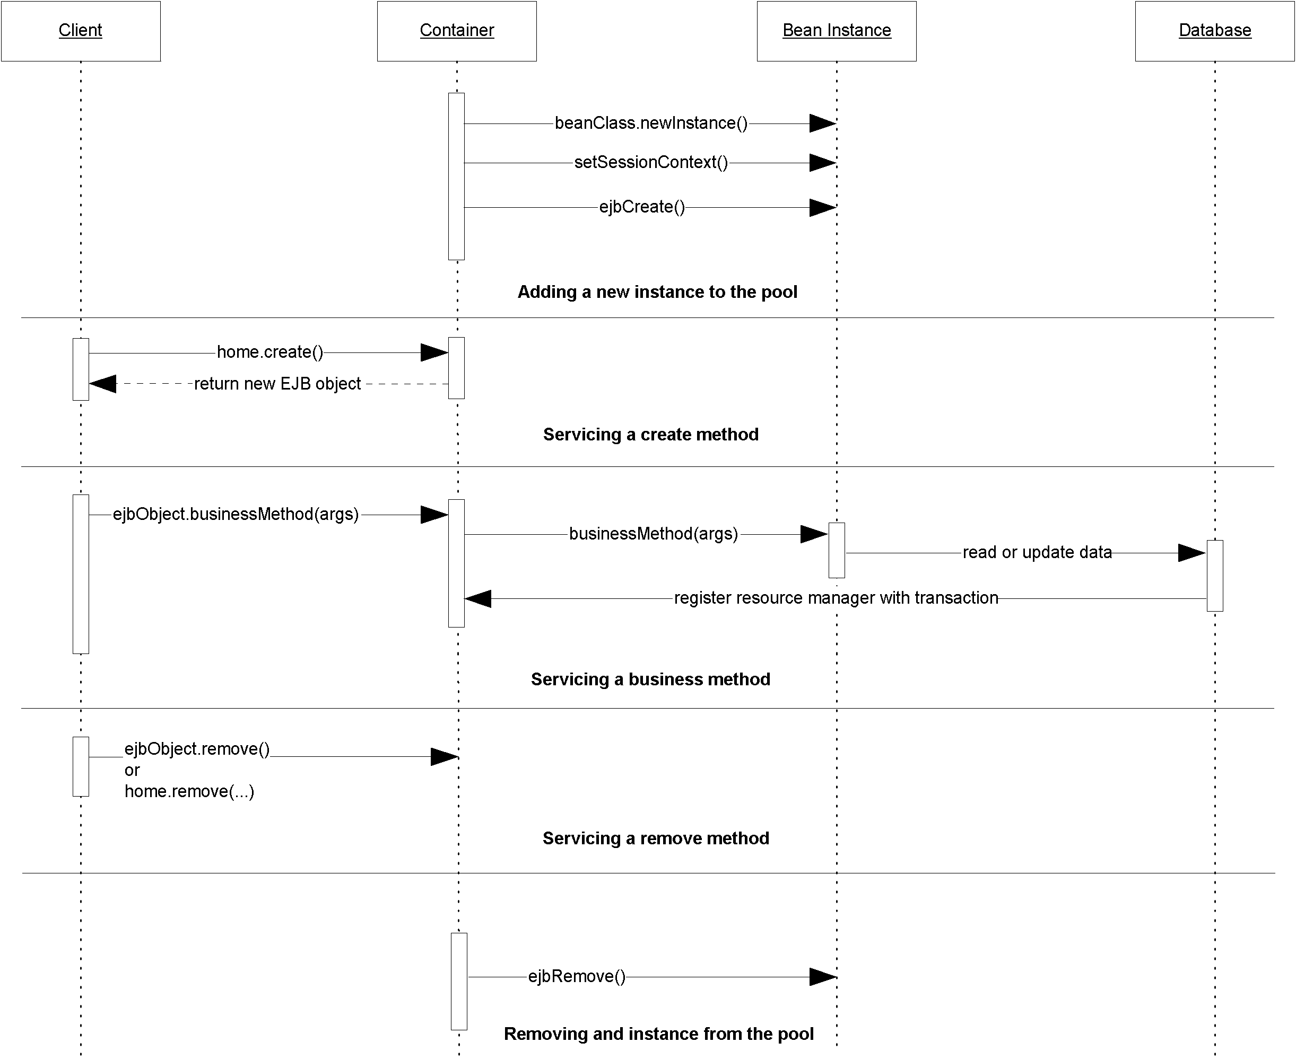
Figure X.X Sequence diagram for stateless session beans. For simplicity, the Container object represents all container subsystems, including EJB objects, home objects, transaction services, and so on.
Stateful Session Bean Diagrams
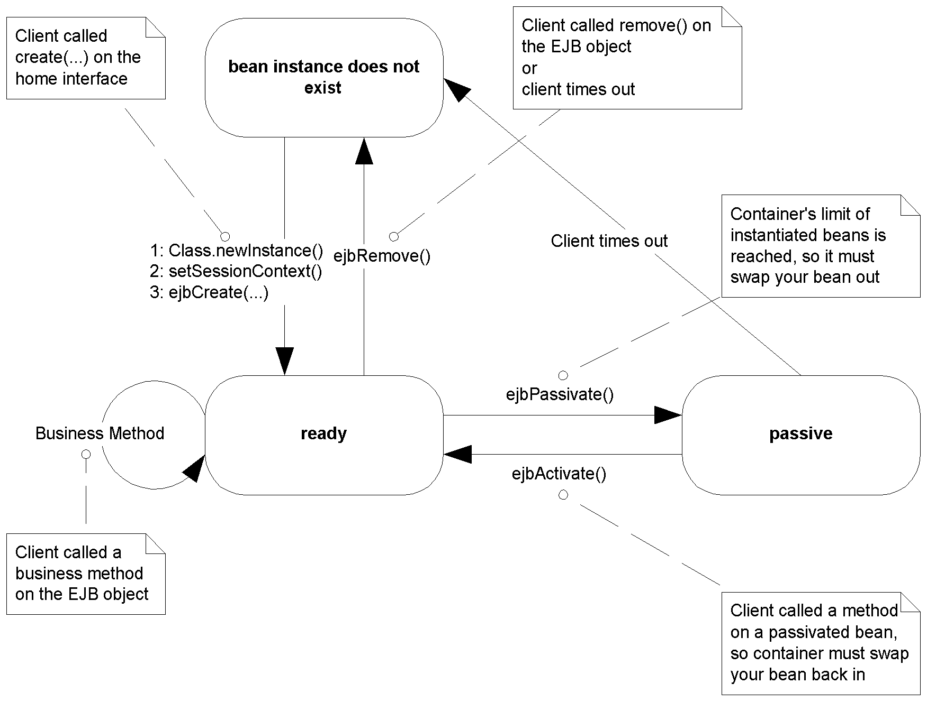
Figure X.X The lifecycle of a stateful session bean (does not implement javax.ejb.SessionSynchronization). Each method call shown is an invocation from the container to the bean instance.
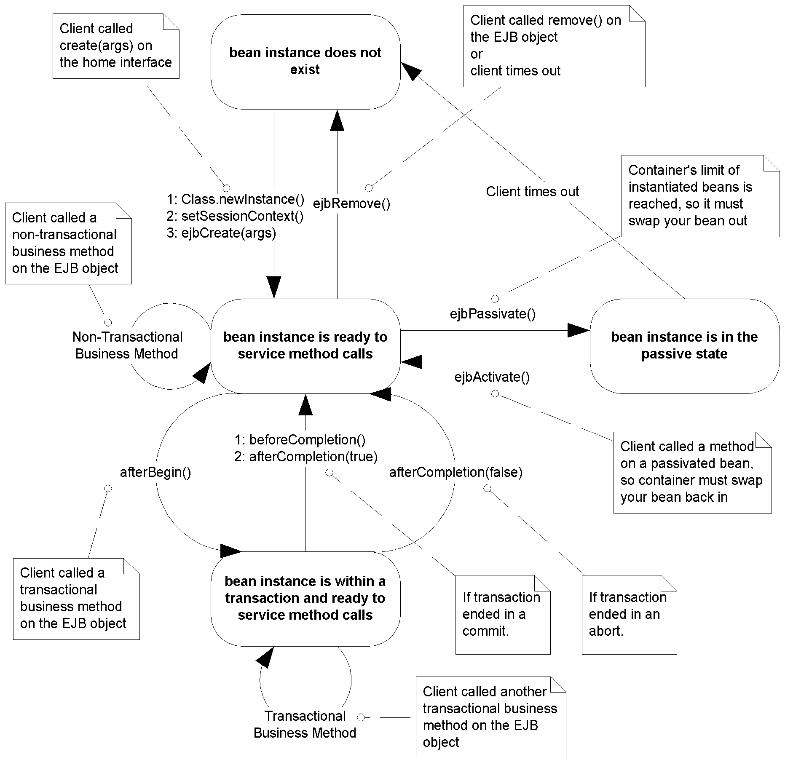
Figure X.X The lifecycle of a stateful session bean (implements javax.ejb.SessionSynchronization). Each method call shown is an invocation from the container to the bean instance.
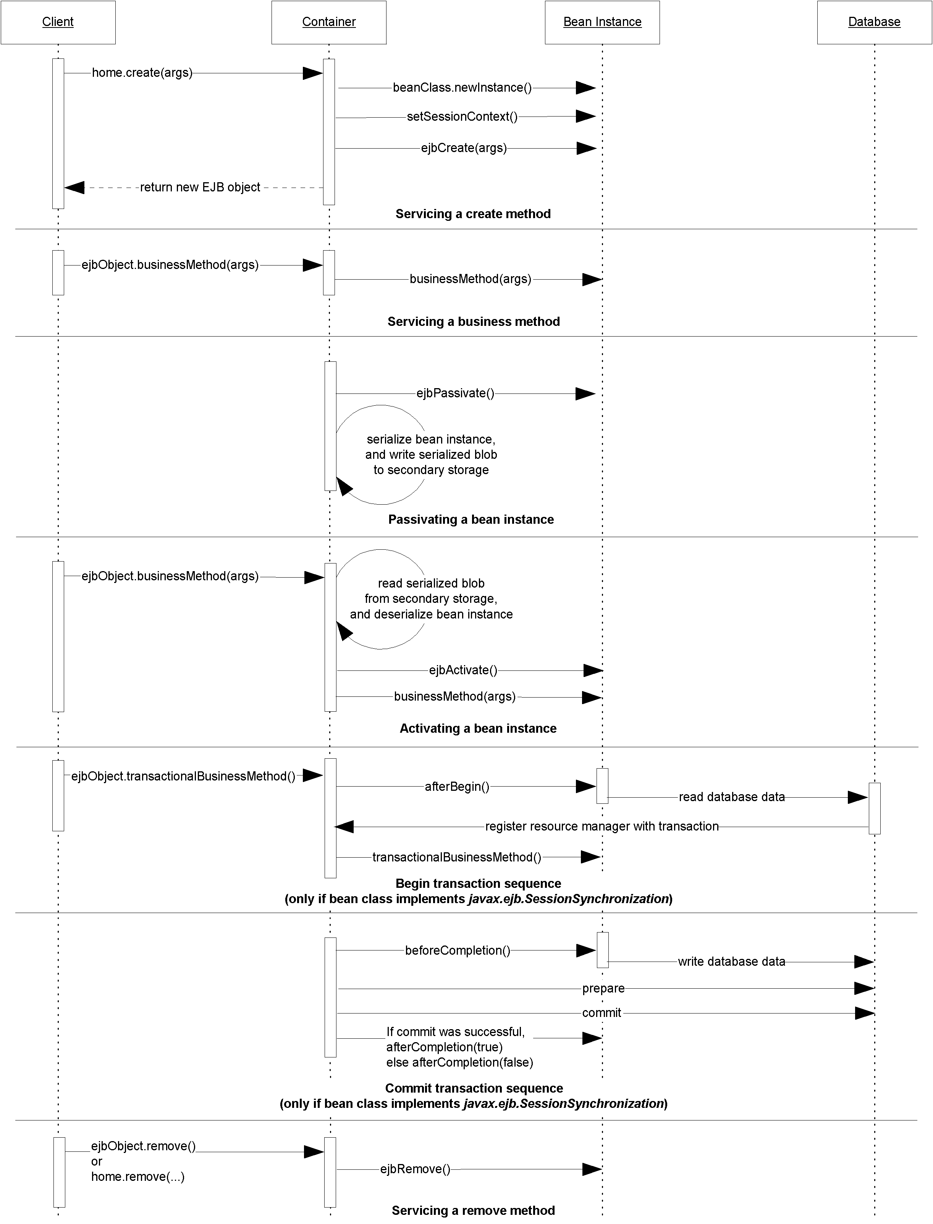
Figure X.X Sequence diagram for stateful session beans. For simplicity, the Container object represents all container subsystems, including EJB objects, home objects, transaction services, and so on.
Entity Bean Diagrams
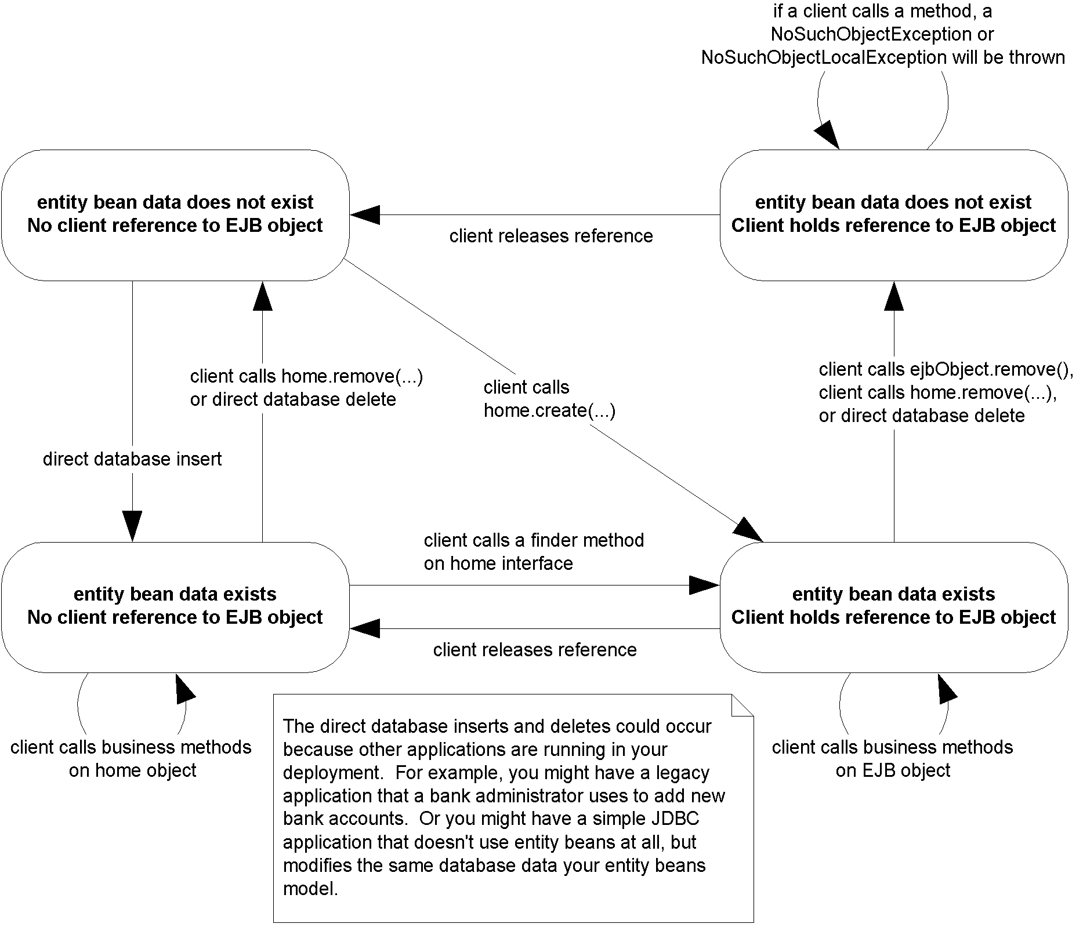
Figure X.X The client’s view of an entity bean object life cycle.
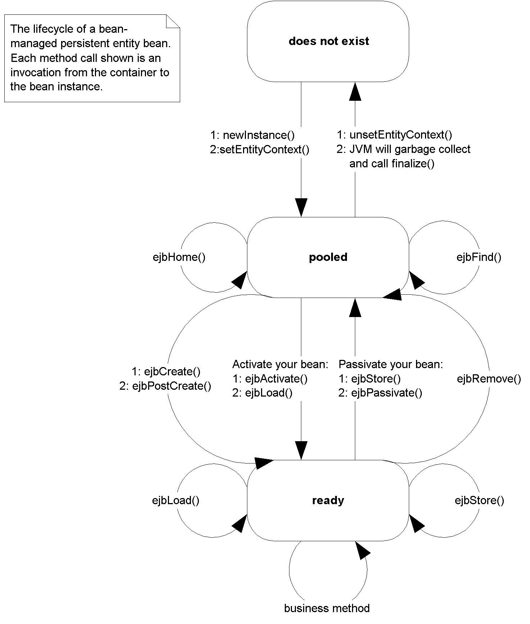
Figure X.X The life cycle of a bean-managed persistent entity bean. Each method call shown is an invocation from the container to the bean instance.
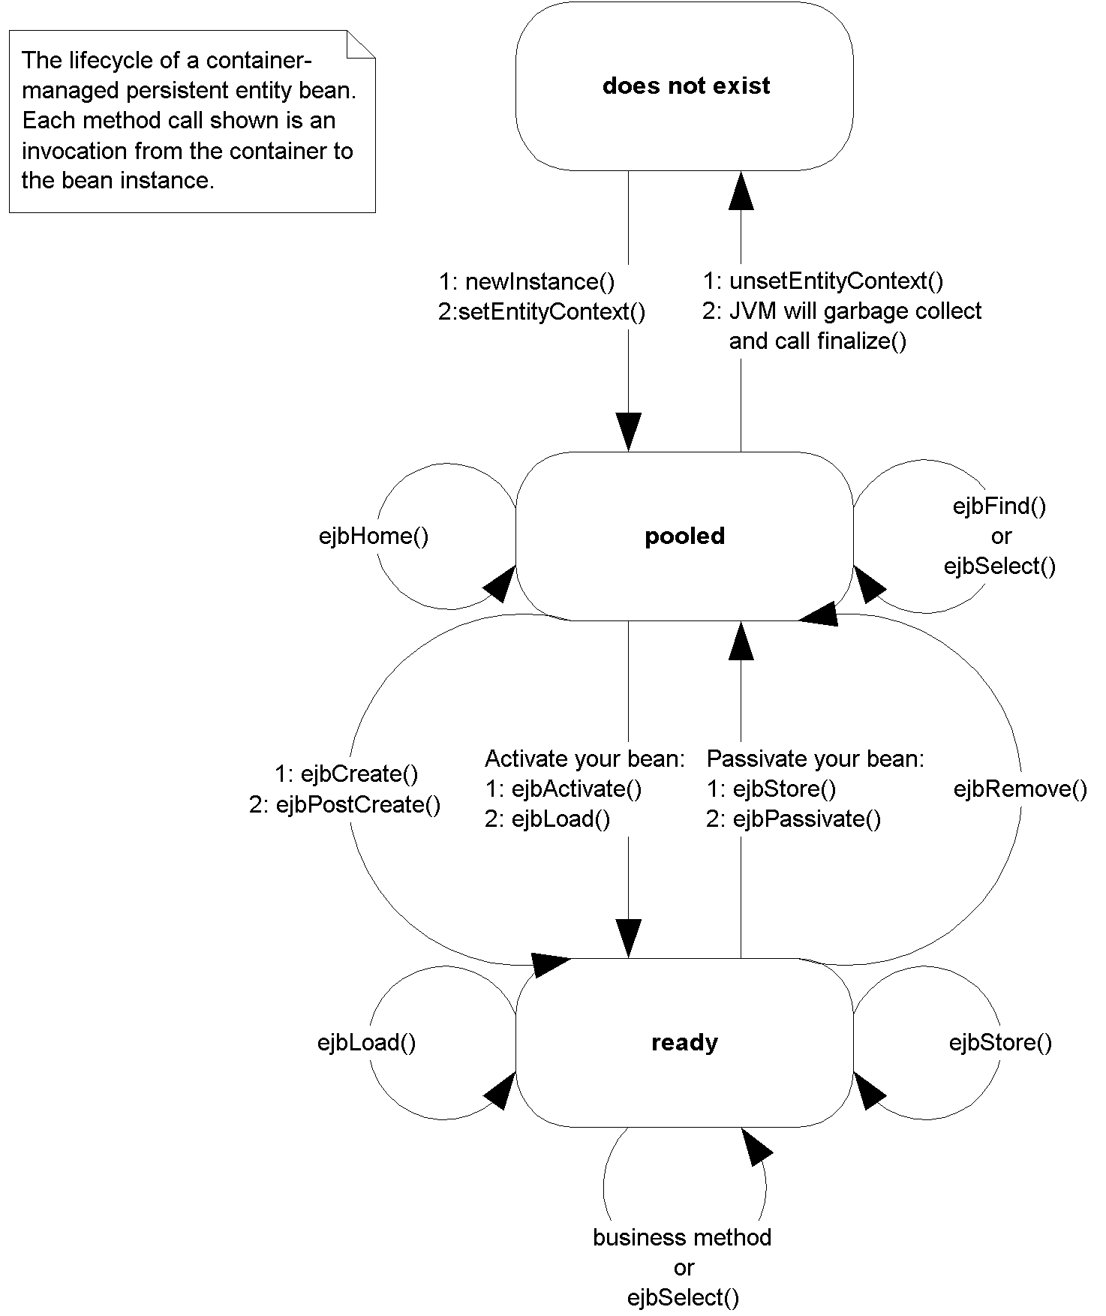
Figure X.X The life cycle of a container-managed persistent entity bean. Each method call shown is an invocation from the container to the bean instance.
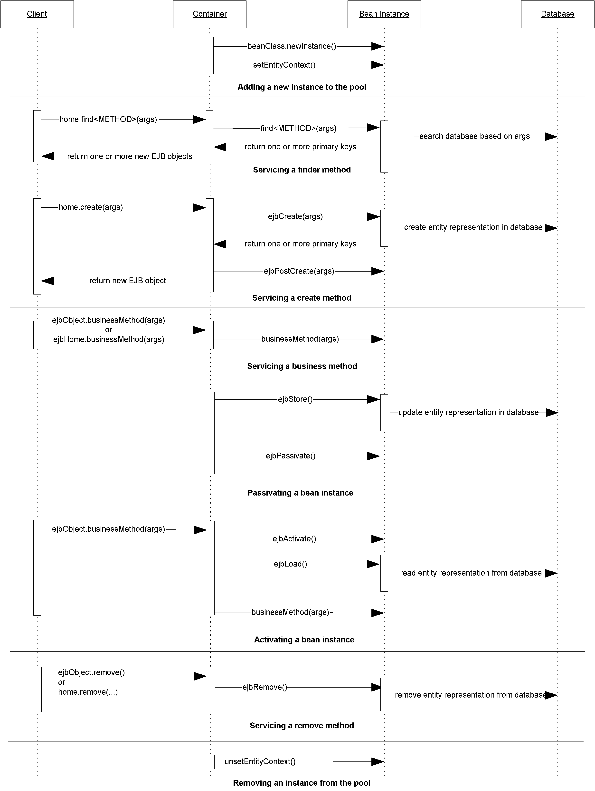
Figure X.X Sequence diagram for bean-managed persistent entity beans. For simplicity, the Container object represents all container subsystems, including EJB objects, home objects, transaction services, and so on.
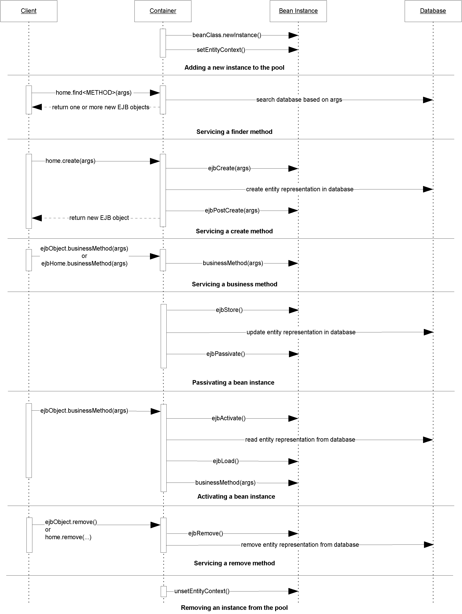
Figure X.X Sequence diagram for container-managed persistent entity beans. For simplicity, the Container object represents all container subsystems, including EJB objects, home objects, transaction services, and so on.
MessageDriven Bean Diagrams

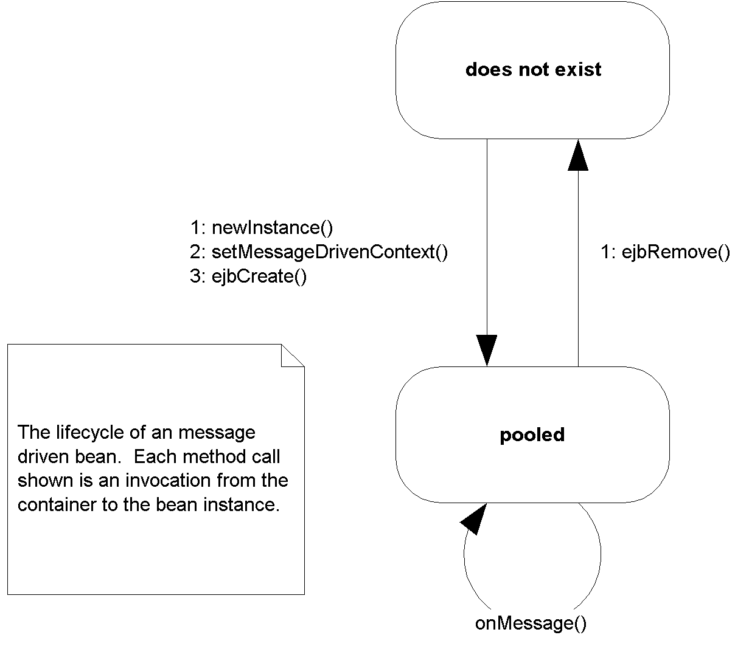
Figure X.X The lifecycle of a message-driven bean. Each method call shown is an invocation from the container to the bean instance.
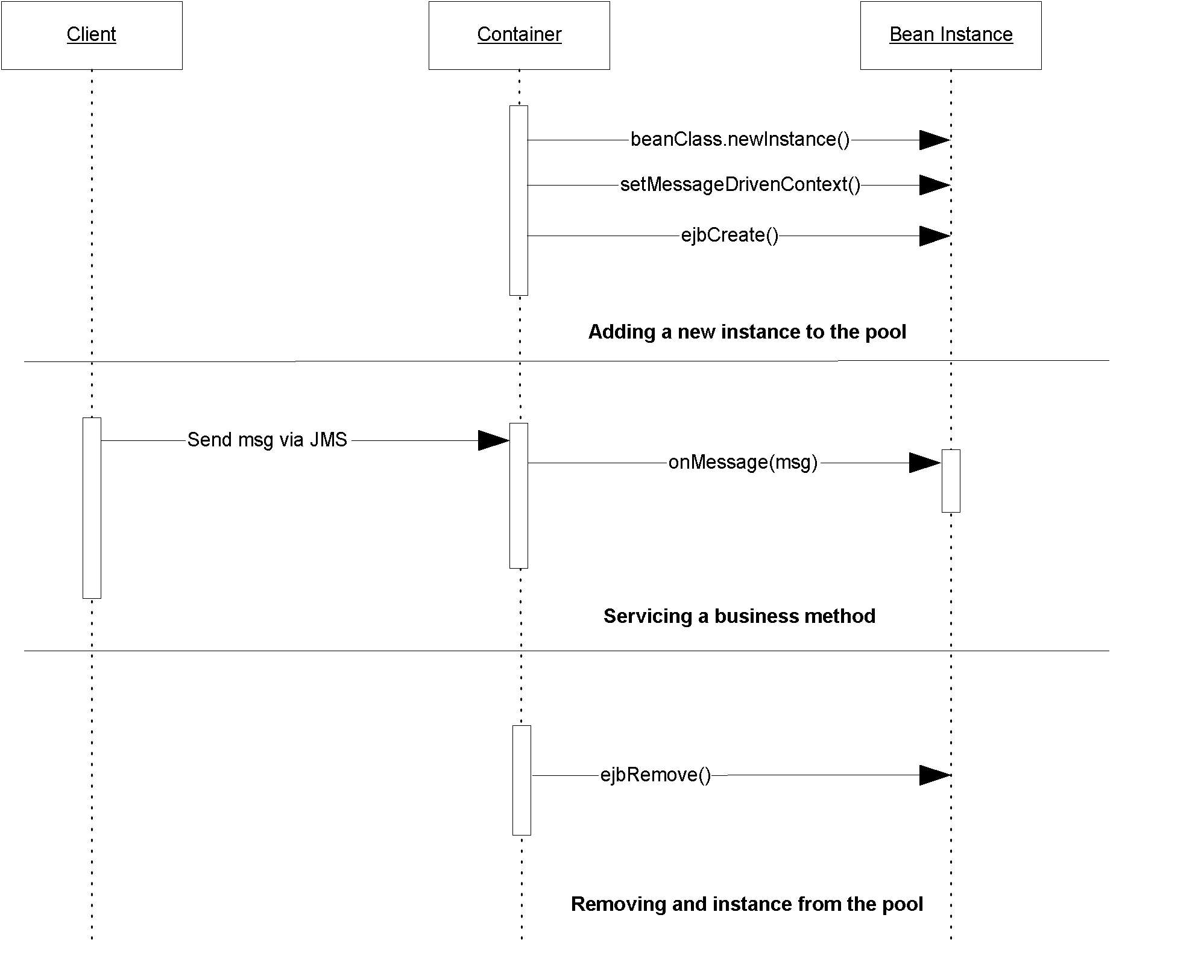
Figure X.X Sequence diagram for message-driven beans. For simplicity, the Container object represents all container subsystems, including home objects, transaction services, and so on.
EJB API Reference
The following section explains the Enterprise JavaBeans API, which is the javax.ejb package. This API is the essence of EJB, and defines the specific signature contracts between clients, enterprise beans, and containers.
EJBHome
Remote clients create, find, and remove EJB objects through home interfaces. Your home interfaces extend javax.ejb.EJBHome. The container will implement the methods in javax.ejb.EJBHome when it implements your home interface as a concrete home object.

public interface javax.ejb.EJBHome
extends java.rmi.Remote
{
public EJBMetaData getEJBMetaData()
throws java.rmi.RemoteException;

public void remove(Handle handle)
throws java.rmi.RemoteException,
javax.ejb.RemoveException;

public void remove(Object primaryKey)
throws java.rmi.RemoteException,
javax.ejb.RemoveException;

public javax.ejb.HomeHandle getHomeHandle()
throws java.rmi.RemoteException;
}

Table X.X javax.ejb.EJBHome (these methods are called by remote clients)
Method | Explanation
getEJBMetaData() | Returns metadata about the enterprise bean you’re working with. Useful if your client code is written in a scripting language, or if you’re writing EJB development tools.
getHomeHandle() | Retrieves a serializable handle to the bean's home object. You can tuck this handle away somewhere (such as writing it to disk) and then use it again later to retrieve the home without performing a JNDI lookup.
remove() | This method destroys an EJB object based upon an EJB object handle or primary key you pass in.
Note: For entity beans, remove() also deletes the bean from the underlying persistent store.
EJBLocalHome
Local clients create, find, and remove local EJB objects through local home interfaces. Your local home interfaces extend javax.ejb.EJBLocalHome. The container will implement the methods in javax.ejb.EJBLocalHome when it implements your local home interface as a concrete local home object.

public interface javax.ejb.EJBLocalHome
{
public void remove(Object primaryKey)
throws javax.ejb.EJBException,
javax.ejb.RemoveException;
}

Table X.X javax.ejb.EJBLocalHome (these methods are called by local clients)
Method | Explanation
remove() | This method destroys an EJB local object based upon a primary key you pass in. Only applies to entity beans. This will also delete the bean data from the underlying persistent store.
EJBLocalObject
A local client accesses a bean through an EJB local object, which implements a local interface. Your local interface must extend javax.ejb.EJBLocalObject. The container will implement the methods in javax.ejb.EJBLocalObject when it implements your local interface as a concrete EJB local object.

public interface javax.ejb.EJBLocalObject
{
public javax.ejb.EJBLocalHome getEJBLocalHome()
throws javax.ejb.EJBException;

public java.lang.Object getPrimaryKey()
throws javax.ejb.EJBException;

public void remove()
throws javax.ejb.EJBException;
javax.ejb.RemoveException;

public boolean isIdentical(javax.ejb.EJBObject)
throws java.rmi.RemoteException;
}
Table X.X javax.ejb.EJBObject
Method | Explanation
getEJBLocalHome() | Gets the local home object for this EJB local object.
getPrimaryKey() | Returns the primary key for this EJB local object. A primary key is only used for entity beans (see Chapter X).
remove() | Destroys this EJB local object. When your client code is done using an EJB local object, you should call this method. The system resources for the EJB local object can then be reclaimed.  Note: For entity beans, remove() also deletes the bean from the underlying persistent store.
isIdentical() | Tests whether two EJB local objects are identical.
EJBMetaData
This interface encapsulates metadata about an enterprise bean. Metadata is not very useful for typical client code, but it more suited towards clients that need to dynamically discover information about an enterprise bean, such as scripting languages or EJB development tools. Your client code can retrieve this metadata by calling homeObject.getEJBMetaData(). The client code will get back a serializable implementation of javax.ejb.EJBMetaData.

public interface javax.ejb.EJBMetaData
{
public javax.ejb.EJBHome getEJBHome();
public java.lang.Class getHomeInterfaceClass();
public java.lang.Class getPrimaryKeyClass();
public java.lang.Class getRemoteInterfaceClass();
public boolean isSession();
public boolean isStatelessSession();
}
EJBObject
A remote client accesses a bean through an EJB object, which implements a remote interface. Your remote interface must extend javax.ejb.EJBObject. The container will implement the methods in javax.ejb.EJBObject when it implements your remote interface as a concrete EJB object.

public interface javax.ejb.EJBObject
extends java.rmi.Remote
{
public javax.ejb.EJBHome getEJBHome()
throws java.rmi.RemoteException;

public java.lang.Object getPrimaryKey()
throws java.rmi.RemoteException;

public void remove()
throws java.rmi.RemoteException,
javax.ejb.RemoveException;

public javax.ejb.Handle getHandle()
throws java.rmi.RemoteException;

public boolean isIdentical(javax.ejb.EJBObject)
throws java.rmi.RemoteException;
}
Table X.X javax.ejb.EJBObject
Method | Explanation
getEJBHome() | Gets the home object for this EJB object.
getPrimaryKey() | Returns the primary key for this EJB object. A primary key is only used for entity beans (see Chapters 7-9).
remove() | Destroys this EJB object. When your client code is done using an EJB object, you should call this method. The system resources for the EJB object can then be reclaimed.  Note: For entity beans, remove() also deletes the bean from the underlying persistent store.
getHandle() | Acquires a handle for this EJB object. An EJB handle is a persistent reference to an EJB object that the client can stow away somewhere. Later on, the client can use the handle to re-acquire the EJB object and start using it again.
isIdentical() | Tests whether two EJB objects are identical.
EnterpriseBean
This interface serves as a marker interface; implementing this interface indicates that your class is indeed an enterprise bean class. You should not implement this interface; rather, implement either javax.ejb.EntityBean, javax.ejb.SessionBean, or javax.ejb.MessageDrivenBean which each extend this interface.

public interface javax.ejb.EnterpriseBean
extends java.io.Serializable
{
}
EntityBean
To write an entity bean class, your class must implement the javax.ejb.EntityBean interface. This interface defines a few required methods that you must fill in. These are management methods that the EJB container calls to alert your bean to life cycle events. Clients of your bean will never call these methods because these methods are not made available to clients via the EJB object.

public interface javax.ejb.EntityBean
implements javax.ejb.EnterpriseBean
{
public void setEntityContext(javax.ejb.EntityContext);
public void unsetEntityContext();
public void ejbRemove();
public void ejbActivate();
public void ejbPassivate();
public void ejbLoad();
public void ejbStore();
}

Each of the above methods can throw a java.rmi.RemoteException or javax.ejb.EJBException.
Table X.X Required methods for Entity Bean classes.
Method | Description | Typical Implementation (Bean-Managed Persistent Entities) | Typical Implementation (Container-Managed Persistent Entities)
SetEntityContext  (EntityContext ctx) | Associates your bean with an entity context. You can query the entity context about your current transactional state, your current security state, and more. | Store the context away in a member variable so the context can be queried later. | Store the context away in a member so the context can be queried later.
ejbFind...(...)  Note: You only use ejbFind() methods with bean-managed persistent entity beans. | Finds an existing entity bean in storage. You can have many different finder methods, which all perform different operations. | Search through a data store using a  storage API such as JDBC or SQL/J. For example, you might perform a relational query such as “SELECT id FROM accounts WHERE balance > 0”. Return the resulting primary key set. | Do not implement these methods for container-managed persistent entity beans. The EJB container will handle all issues relating to finding data for you. Use your container tools to describe your finder method needs.
ejbSelect...(...)  Note: You only use ejbSelect() methods with container-managed persistent entity beans | ejbSelect() methods are CMP helper methods that perform queries internally by your bean, but are not accessible to clients of your bean. | There are no ejbSelect() methods for BMP entity beans. You can write your own helper methods and name them whatever you wish. | Define this method as abstract. Then write EJB-QL in the deployment descriptor to setup the query.
ejbHome...(...) | Sometimes you need methods on an entity bean that are not specific to any given data instance (or row). For example, counting up the total number of accounts in a table. You can write ejbHome methods to perform these operations. The ejbHome methods are special business methods because they are called from a bean in the pool, before the bean is associated with any specific data. Clients call these methods from the home interface or local home interface. | Perform your 'global' operations, such as counting up the rows in a database, and returning the results to the client. The fast-and-easy way to achieve this is to use JDBC. The cleaner (but lower-performing way if you're not careful) is to call ejbSelect() and perhaps other entity bean methods. | Perform your 'global' operations, such as counting up the rows in a database, and returning the results to the client. The fast-and-easy way to achieve this is to use JDBC. The cleaner (but lower-performing way if you're not careful) is to call ejbSelect() and perhaps other entity bean methods.
ejbCreate...(...) | Initializes a bean for a particular, and creates underlying database data. Each ejbCreate() method you define gives clients a different way to create your entity beans. | Validate the client’s initialization parameters. Explicitly create the database representation of the data via a storage API such as JDBC or SQL/J. | Validate the client’s initialization parameters. Call your abstract set() methods to initialize the generated bean subclass to the parameters passed in. The container will then use these values in the subclass to create the database data for you.
ejbPostCreate...(...) | Your bean class must define ejbPostCreate() for each one ejbCreate(). Each pair must accept the same parameters. The container calls ejbPostCreate() right after ejbCreate(). | Perform any initialization you need to that requires a reference to your own EJB object, such as passing your bean’s EJB object reference to other beans. You can get your EJB object via entityContext. getEJBObject(). | Perform any initialization you need to that requires a reference to your own EJB object, such as passing your bean’s EJB object reference to other beans. You can get your EJB object via entityContext. getEJBObject().
ejbPassivate() | Called immediately before your bean is passivated (swapped out to disk because there are too many beans instantiated). | Release any resources your bean may be holding. | Release any resources your bean may be holding.
ejbStore() | Called when the container needs to update the database with your bean’s state. The current transactional state dictates when this method is called. This method is also called during passivation, directly before ejbPassivate(). | Explicitly update the database representation of the data via a storage API such as JDBC. Typically, you’ll write a number of your ember variable’s fields out to disk. | Do not update the database in this method. Rather, the EJB container will update the database for you automatically right after calling your ejbStore() method. It does this in the subclass by taking your bean state and writing it to the database. Thus, you should prepare your state to be written to the database, such as compressing fields, by calling your abstract get/set methods.
ejbLoad() | Called when the container needs to update your bean with the database’s state. The current transactional state dictates when this method is called. This method is also called during activation, directly before ejbActivate(). | First, your bean instance must figure out what data it should load. Call the getPrimaryKey() method on the entity  context; that will tell your bean what data it should be loading. Next, read database data into your bean via a storage API such as JDBC or SQL/J. | Do not read data from the database in this method. Rather, the EJB container will read in data from the database for you automatically right before calling your ejbLoad() method. It does this in the subclass by querying the database and populating your bean state. Thus, you should perform any necessary post-load operations, such as decompressing fields, by calling your abstract get/set methods.
ejbActivate() | Called immediately before your bean is activated (swapped in from disk because a client needs your bean). | Acquire any resources your bean needs, such as those released during ejbPassivate(). | Acquire any resources your bean needs, such as those released during ejbPassivate().
ejbRemove() | To destroy an entity bean’s data in a database, the client must call remove() on the EJB object or home object. This method causes the container to issue an ejbRemove() call on the bean. ejbRemove() is a required method of all beans, and takes no parameters.  Note: ejbRemove() does not mean the in-memory entity bean instance is going to be destroyed--ejbRemove() only destroys database data. The bean instance can be recycled to handle different database data, such as a bank account bean representing different bank accounts. | First, figure out what data you should be destroying via getPrimaryKey() on the EntityContext. Then explicitly delete the database representation of the data via a storage API such as JDBC or SQL/J. | Do not destroy database data in this method. Rather, simply perform any operations that must be done before the data in the database is destroyed. The EJB container will destroy the data for you right after ejbRemove() is called.
unsetEntityContext() | Called right before your entity bean instance is destroyed (when the container wants to reduce the pool size). | Release any resources you allocated during setEntityContext(), and get ready to be garbage collected | Release any resources you allocated during setEntityContext(), and get ready to be garbage collected
EntityContext
An entity context is a specific EJB context used only for entity beans.

public interface javax.ejb.EntityContext implements
javax.ejb.EJBContext
{
public javax.ejb.EJBObject getEJBLocalObject()
throws IllegalStateException;

public javax.ejb.EJBObject getEJBObject()
throws IllegalStateException;

public java.lang.Object getPrimaryKey();
throws IllegalStateException;
}
Table X.X javax.ejb.EntityContext
Method | Description | Usefulness
getEJBLocalObject() | Returns a reference to your  bean’s own local EJB object. | Useful if your bean needs to call another local bean, and you want to pass a reference to yourself.
getEJBObject() | Returns a reference to your  bean’s own remote EJB object. | Useful if your bean needs to call another remote bean, and you want to pass a reference to yourself.
getPrimaryKey() | Retrieves the primary key that is currently associated with this entity bean instance. | Call to determine what database data your instance is associated with. You need to use this in  ejbLoad() to determine what database data to load and in ejbRemove() to determine what database data to remove.
Handle
An EJB object handle is a persistent reference to an EJB object. Handles allow you to disconnect from your EJB server, shut your application down, and later resume your application while preserving the conversational state in the beans you’ve been working with. Home handles are also useful when your client code needs to store a reference to an EJB object in stable storage and re-connect to that EJB object later.

public interface javax.ejb.Handle
{
public javax.ejb.EJBObject getEJBObject();
}
HomeHandle
Just as an EJB object handle is a persistent reference to an EJB object, a home handle is a persistent reference to a home object. Home handles are useful when your client code needs to store a reference to a home object in stable storage and re-connect to that home object later. Home handles allow you to avoid doing a JNDI lookup when re-connecting to a home object.

public interface javax.ejb.HomeHandle
{
public javax.ejb.EJBHome getEJBHome();
}
MessageDrivenBean
To write a message-driven bean class, your class must implement the javax.ejb.MessageDrivenBean interface. This interface defines a few required methods that you must fill in. These are management methods that the EJB container calls to alert your bean about life cycle events. Clients of your bean will never call these methods because clients do not call message-driven beans directly; rather, they send messages using the Java Message Service (JMS).

public interface javax.ejb.MessageDrivenBean
extends javax.ejb.EnterpriseBean
{
public void setMessageDrivenContext(MessageDrivenContext ctx);
public void ejbRemove();
}

Each of these methods can throw a javax.ejb.EJBException.
Table X.X Required methods for MessageDriven Bean classes.
Method | Description | Typical Implementation
setMessageDrivenContext  (MessageDrivenContext ctx) | Associates your bean with a message-driven context. Your bean can query the context about its current transactional tate, retrieve its own home object, and more. | Store the context away in a member variable so the context can be queried later.
ejbCreate() | Initializes your message-driven bean. You can only define a single ejbCreate() method which takes no parameters. This is called directly after you are associated with a context object. | Perform any initialization your bean needs, such as locating external resources, or looking up other EJB home objects to be used later.
onMessage(message) | Your bean has received a new message. | Crack open the message, figure out what it means to you, process the message, and perform any logic you desire.
ejbRemove() | Called by the container immediately before your bean is removed from memory. | Prepare your bean for destruction. Free all resources you may have allocated.
MessageDrivenContext
A message-driven context is a specific EJB context used only for message-driven beans. This interface serves as a marker interface. There are no specific additional methods that message-driven beans get on their context objects.

public interface javax.ejb.MessageDrivenContext
extends javax.ejb.EJBContext
{
}
SessionBean
To write a session bean class, your class must implement the javax.ejb.SessionBean interface. This interface defines a few required methods that you must fill in. These are management methods that the EJB container calls to alert your bean about life cycle events. Clients of your bean will never call these methods because these methods are not made available to clients via the EJB object.

public interface javax.ejb.SessionBean
extends javax.ejb.EnterpriseBean
{
public void setSessionContext(SessionContext ctx);
public void ejbPassivate();
public void ejbActivate();
public void ejbRemove();
}

Each of these methods can throw a java.rmi.RemoteException or javax.ejb.EJBException.
Table X.X Required methods for Session Bean classes.
Method | Description | Typical Implementation
setSessionContext  (SessionContext ctx) | Associates your bean with a  session context. Your bean can query the context about its current transactional tate, its current security state, and more. | Store the context away in a member variable so the context can be queried later.
ejbCreate...(...) | Initializes your session bean. You can define several ejbCreate...(...) methods, and each can take different arguments. You must provide at least one ejbCreate...(...) method in your session bean. | Perform any initialization your bean needs, such as setting member variables to the argument values passed in.
ejbPassivate() | Called immediately before your bean is passivated (swapped out to disk because there are too many beans instantiated). Does not apply to stateless session beans. | Release any resources your bean may be holding.
ejbActivate() | Called immediately before your bean is activated (swapped in from disk because a client needs your bean). Does not apply to stateless session beans. | Acquire any resources your bean needs, such as those released during ejbPassivate().
ejbRemove() | Called by the container immediately before your bean is removed from memory. | Prepare your bean for destruction. Free all resources you may have allocated.
SessionContext
A session context is a specific EJB context used only for session beans.

public interface javax.ejb.SessionContext
extends javax.ejb.EJBContext
{
public javax.ejb.EJBLocalObject getEJBLocalObject()
throws IllegalStateException;

public javax.ejb.EJBObject getEJBObject()
throws IllegalStateException;
}
Table X.X javax.ejb.SessionContext
Method | Description | Usefulness
getEJBLocalObject() | Returns a reference to your bean’s own local EJB object. | Useful if your bean needs to call another local bean, and you want to pass a reference to yourself.
getEJBObject() | Returns a reference to your bean’s own EJB object. | Useful if your bean needs to call another bean, and you want to pass a reference  to yourself.
SessionSynchronization
If your stateful session bean is caching database data in memory, or if it needs to rollback in-memory conversational state upon a transaction abort, you should implement this interface. The container will call each of the methods in this interface automatically at the appropriate times during transactions, alerting you to important transactional events.

public interface javax.ejb.SessionSynchronization
{
public void afterBegin();
public void beforeCompletion();
public void afterCompletion(boolean);
}

Each of these methods can throw a java.rmi.RemoteException or javax.ejb.EJBException.
Table X.X javax.ejb.SessionSynchronization
Method | Description
afterBegin() | Called by the container directly after a transaction begins. You should read in any database data you want to cache in your stateful session bean during the transaction. You should also create a backup copy of your state in case the transaction rolls back.
beforeCompletion() | Called by the container right before a transaction completes. Write out any database data you’ve cached during the transaction.
afterCompletion(boolean) | Called by the container when a transaction completes either in a commit or an abort--true indicates a successful commit, false indicates an abort. If an abort happened, you should revert back to the backup copy of your state to preserve your session bean’s conversation.
Exception Reference
The following table describes the purpose of each exception class in EJB.
Table X.X EJB Exception explanations
Exception | Description
AccessLocalException | Indicates the client does not have permission to call this method. Only used for local clients.
CreateException | This exception type indicates failure to create an enterprise bean. You should throw this exception in your home interface’s create(...) methods.
DuplicateKeyException | This exception type indicates failure to create an entity bean because an entity bean with the same primary key already exists. This is a subclass of CreateException and is thrown in an entity bean home interface’s create(...) methods.
EJBException | Your enterprise bean class should throw this exception to indicate an unexpected error, such as a failure to open a database connection, or a JNDI exception. Your container will treat this exception as a serious problem, and may take action such as logging the event or paging a system administrator, depending upon your container’s policy. The container will then rethrow a java.rmi.RemoteException if the client is remote, or a javax.ejb.EJBException if the client is local. Since EJBException is a RuntimeException it does not need to be declared in throws clauses.
FinderException | This exception indicates a failure to locate an existing entity bean. You should throw this method from your home interface’s finder methods.
NoSuchEntityException | Your entity bean class should throw this exception to indicate that the database data corresponding to the in-memory entity bean instance has been removed. You can throw this exception from any of your entity bean class’ business methods, and from your ejbStore and ejbLoad methods.
NoSuchObjectLocalException | Thrown when a client tries to call a method on a bean that has been destroyed.
ObjectNotFoundException | When you’re writing finder methods in your entity bean’s home interface, you should throw this exception to indicate that the specified EJB object was not found. You should only use this exception when your finder method is returning a single EJB object. If you’re returning more than one EJB object, a null collection is returned instead.
RemoveException | Your enterprise bean should throw this exception when an error occurrs during ejbRemove(). The container will rethrow this exception back to the client. This is considered a normal, run-of-the-mill application-level exception and does not indicate a systems-level problem. When your client code receives this exception, you do not know for sure whether the entity bean has been removed or not.
TransactionRequired LocalException | Indicates the receiving object needed a transaction to run, but was not supplied with a transaction context.
TransactionRolledBack LocalException | Indicates the request's transaction was rolled back, or marked for roll-back. Thus the request could not be completed.
Transaction Reference

Transaction attribute | Client's transaction | Bean's Transaction
Required | none | T2
Required | T1 | T1
RequiresNew | none | T2
RequiresNew | T1 | T2
Supports | none | none
Supports | T1 | T1
Mandatory | none | error
Mandatory | T1 | T1
NotSupported | none | none
NotSupported | T1 | none
Never | none | none
Never | T1 | error
Table X.X The effects of transaction attributes

Table X.X Transaction Attributes
Constant | Meaning
NotSupported | Your bean cannot be involved in a transaction at all. When a bean method is called, any existing transaction is suspended.
Never | Your bean cannot be involved in a transaction at all. When a bean method is called, if a transaction is in progress, an exception is thrown back to the client (java.rmi.RemoteException if remote, javax.ejb.EJBException if local).
Required | Your bean must always run in a transaction. If there’s already a transaction running, your bean joins in on that transaction. If there is no transaction running, the EJB container starts one for you.
RequiresNew | Your bean must always run in a new transaction. Any current transaction is suspended.
Supports | If a transaction is already underway, your bean will join that transaction. Otherwise, the bean runs with no transaction at all.
Mandatory | Mandates that a transaction must be already running when your bean method is called, else a javax.ejb.TransactionRequired exception is thrown back to the caller.

Table X.X Permissible transaction attributes for each bean type
Transaction Attribute | Stateless Session Bean | Stateful Session Bean implementing SessionSynchronization | Entity Bean | Message-driven bean
Required | Yes | Yes | Yes | Yes
RequiresNew | Yes | Yes | Yes | No
Mandatory | Yes | Yes | Yes | No
Supports | Yes | No | No | No
NotSupported | Yes | No | No | Yes
Never | Yes | No | No | No

Table X.X0 Transaction Isolation Levels
Isolation Level | Dirty Reads? | Unrepeatable Reads? | Phantom Reads?
READ UNCOMMITTED | Yes | Yes | Yes
READ COMMITTED | No | Yes | Yes
REPEATABLE READ | No | No | Yes
SERIALIZABLE | No | No | No

Table X.X1 The javax.transaction.Status Constants for Transactional Status
Constant | Meaning
STATUS_ACTIVE | A transaction is currently happening and is active.
STATUS_NO_TRANSACTION | There is no transaction currently happening.
STATUS_MARKED_ROLLBACK | The current transaction will eventually abort because it’s been marked for rollback. This could be because some party called setRollbackOnly().
STATUS_PREPARING | The current transaction is preparing to be committed (during Phase One of the two-phase commit protocol).
STATUS_PREPARED | The current transaction has been prepared to be committed (Phase One is complete).
STATUS_COMMITTING | The current transaction is in the process of being committed right now (during Phase Two).
STATUS_COMMITTED | The current transaction has been committed (Phase Two is complete).
STATUS_ROLLING_BACK | The current transaction is in the process of rolling back.
STATUS_ROLLEDBACK | The current transaction has been rolled back.
STATUS_UNKNOWN | The status of the current transaction cannot be determined.

Table X.X2 The javax.transaction.UserTransaction Methods for Transactional Boundary Demarcation
Method | Description
begin() | Begin a new transaction. This transaction becomes associated with the current thread.
commit() | Run the two-phase commit protocol on an existing transaction associated with the current thread. Each resource manager will make its updates durable.
getStatus() | Retrieve the status of the transaction associated with this thread.
rollback() | Force a rollback of the transaction associated with the current thread.
setRollbackOnly() | Call this to force the current transaction to rollback. This will eventually force the transaction to abort. One interesting use of this is to test out what your components will do, without having them perform any permanent resource updates.
setTransactionTimeout(int) | The transaction timeout is the maximum amount of time that a transaction can run before it’s aborted. This is useful to avoid deadlock situations, when precious resources are being held by a transaction that is currently running.

